

**Winners from globalisation**

Speech given by

Ben Broadbent, Deputy Governor Monetary Policy, Bank of England

Scottish Council for Development and Industry, Aberdeen 11 July 2017

I’d like to thank Will Abel, Alina Barnett, Gene Kindberg-Hanlon and Jeremy Martin along with other colleagues for their helpful comments and assistance.

Two hundred and fifty years ago, a few miles south of here, Adam Smith began working on the Wealth of Nations. It was published a decade later, in 1776. So there were (at least) two revolutions that year, one marking the birth of a country, the other the birth of modern economics.

One of Smith’s main targets was the doctrine of mercantilism – the idea that international trade is a zero sum game, one you win by exporting more than your neighbour. He pointed out that, if it allows you to concentrate on things you do relatively well, and buy more cheaply the stuff that others do well, international trade can make both parties better off.

A precise definition of “relatively well”, in this context, had to wait until David Ricardo’s Principles of Political Economy, published in 1817. What matters for trading patterns, he explained, was not just absolute advantage – whether a domestic sector was more productive than its peers in other countries – but also its productivity relative to other sectors at home (“comparative advantage”). This was important, because it meant that, in principle, a country could have lower productivity across the board, in the production of every good, and still end up as a net exporter of some of them. But the basic points survive: there’s no reason to suppose that commerce across an international border is any less mutually beneficial than that within a single country; nor is there any reason to view imports as intrinsically bad.

Of course, you might feel differently if you happen to be in one of the sectors at a comparative disadvantage. In the mid-1970s, just as the post-war boom in global trade was getting started, the UK’s clothing and textile industry employed over 800,000 people. That’s one in every 30 jobs. As markets opened up international prices fell steeply and, over the following thirty years or so, the domestic industry all but collapsed. Output fell 65%, employment by 90%. It now accounts for one in every 370 jobs.

Not all of this reflects the effects of greater trade. Part of the post-war decline in textile employment – employment in manufacturing in general, in fact – reflected relatively rapid productivity growth, not cheaper imports. If it takes progressively fewer people to make the same amount of stuff you might expect employment to fall. Over time the share of jobs in manufacturing has fallen in every developed country, including in those regarded as industrial powerhouses, such as Germany and Japan.

But there’s little doubt that, for the UK’s clothing and textile businesses, globalisation mattered a great deal. And if you’re inclined to view de-industrialisation as a sorry tale, it can only be the sorrier for a sector that played such a prominent part in our history and in the industrial revolution in particular. During the ten years Adam Smith spent writing the Wealth of Nations, and a few miles further south of here, the inventor and entrepreneur Richard Arkwright was awarded patents for his new spinning and carding machines. He opened his famous mill at Cromford in 1776, the same year as the book was published. By 1790 mills using his new machines employed 30,000 people. By the 1820s, Britain was producing half of the global cotton

textiles1. Famously, in his two-sector example of the principle of comparative advantage, Ricardo chose Portuguese wine and “English cloth”.

And yet it is still worth bearing in mind Smith and Ricardo’s basic insights. If people can move relatively easily from one job to another, employment needn’t fall in aggregate even if it’s doing so in one particular sector. (Nationally, the rate of employment is significantly higher and the rate of unemployment far lower than in the mid-1970s.) And in the meantime, we have all had the benefit of cheaper clothes. Those as long in the tooth as me will know that, even in nominal terms, it costs less to buy a pair of jeans and a t-shirt today than it did thirty or forty years ago. The result is a significant contribution to real income growth over that period.

In what follows I’ll flesh out these numbers a little further and say something too about their distributional effects. (One particular point in this respect is that the real income benefit of lower import prices is probably most marked for those at the lower end of the distribution.) I’ll mention the parallels, long recognised by economists, between the effects of growing trade and those of technical progress, and the role of the latter in rising inequality in the US. I’ll conclude with some remarks about the sort of things economists might have to think about as the UK leaves the EU.

# Globalisation and its effects on UK clothing

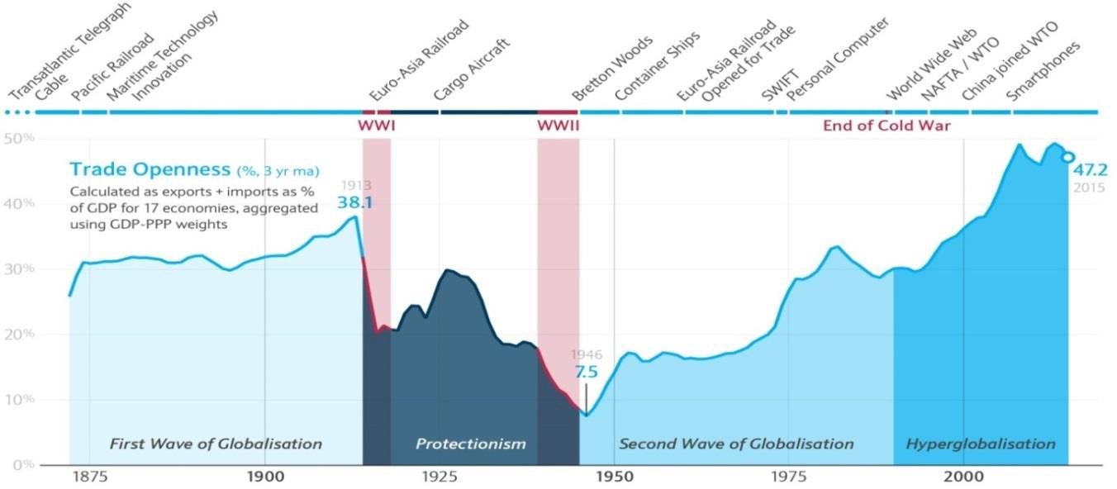Globalisation hasn’t occurred smoothly nor is there a single, discrete date at which it began. Its broad features are reasonably clear in Charts 1 and 2.

|  |
| --- |
| **Chart 1: Globalisation: a timeline** |
| Source: NBER Macrohistory Database and Barclays calculations (Keller et al 2017) |

1. D. N. McCloskey, "The Industrial Revolution in Britain 1780-1860: A Survey," in Roderick Floud and Donald McCloskey, The Economic History of Britain since 1700.

One is that the current extent of world trade isn’t entirely novel and should in some ways be seen as a recovery. World trade had grown very strongly under the classical gold standard, during the second half of the 19th century. The same goes for the capital flows that financed these exchanges. The catastrophes of the world wars, and the intervening Great Depression, put all that into reverse. Partly as a natural consequence of economic contraction, partly thanks to outright protectionism, trade volumes fell sharply between 1914 and 1950, even relative to world GDP.

|  |  |
| --- | --- |
| **Chart 2: Costs of trade fell sharply in 1970s** | Second, although the conditions for a revival began to be laid during the 1950s2 it wasn’t until the 1960s and early 1970s that trade costs started to fall, and trade intensity to rise, in earnest. In this first phase of (re-)globalisation, during the 1970s and 80s, much of the growth in trade occurred between developed economies.  Third, there was a further and very marked rise in trade intensity during the 1990s and the early part of the last decade, as developing economies  entered the world trading system. |
| Source: Jacks , Meissner, and Novy (2011) |  |

Finally, you can see clearly how world trade has stalled, relative to GDP, since the financial crisis a decade ago.

This is to cut a long and complex story very short. But you can I think see a broad-brush correspondence between these high-level developments and the more specific trends in the UK’s clothing and textile sector.

Until the early to mid-1970s import penetration was roughly stable and real clothes prices fell at the relatively gentle pace of 1% or so a year (Charts 3 and 4). We’ve seen the same broad stability, in both trade and prices, in the years since the financial crisis, during which global trade growth has also slowed. But the years in between saw a marked rise in import penetration and very rapid declines in real UK clothes prices, particularly over the second half of that period.

1. Tariffs began to fall in the 1950s, container ships, which materially reduced shipping costs, were first developed later that decade, and the first regional trade agreements (notably the EEC) were made in the 1960s.

# Chart 3: Import penetration started growing in 1970s, rose strongly in 90s, stable post-crisis

**Chart 4: Real UK clothes prices fell steeply between mid-1970s and the crisis**

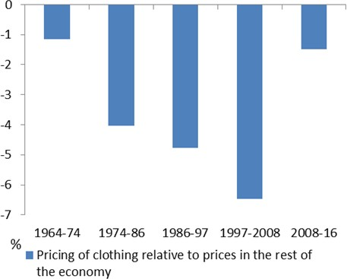clothing and textile imports, % of consumption

35

30

25

20

15

10

1965 1970 1975 1980 1985 1990 1995 2000

Source: ONS and UN Comtrade Database Source: ONS

Cumulatively, those declines were pretty spectacular. Even in nominal terms, clothes in the UK were on average cheaper in 2008 than they had been in 1975 (Chart 5). That’s quite something given the general rate of inflation in the 1970s and 80s. In real terms – relative to the rest of the consumer basket – they fell by over 80%.

This has brought significant benefits for consumers. It’s hard to say what would’ve happened in the absence of globalisation. But let’s suppose that, in that event, real clothes prices would have continued to fall at the 1%-or-so pace we saw prior to the mid-1970s (and since 2008). By comparison the actual decline in prices over the past 40 years has added just over 3% to real household incomes.

At the same time the domestic production sector has clearly suffered (Chart 6). It didn’t start in a great position, it should be said. In 1975 it was a comparatively unproductive industry: per capita value added was 30% below the UK average. It required and employed relatively low-skilled labour: the average full-time wage was £1,730 a year – barely £5 per hour in today’s money and over a third lower than in the rest of the economy. Even then the country was buying more clothes than it produced: the balance of trade in clothing and textiles was already in deficit. Ricardo may have chosen British cloth as his quintessential example of a comparative advantage. But by the 1970s, if not long before, the position had been reversed. Faster productivity growth in the same sector in other countries, and in other sectors at home, had turned that into a comparative disadvantage.

Whatever its starting position the subsequent declines in prices were far more than the domestic industry could bear. Since the mid-1970s domestic output has shrunk by two thirds, domestic employment by 90%. If ever there was a loser from globalisation the UK’s clothing and textile industry would surely qualify as one.

# Chart 5: Even in nominal terms clothes are cheaper than in the 1970s

price index, 1975=100

800

Rest of consumption Clothes

600

400

200

0

1975 1985 1995 2005 2015

# Chart 6: Globalisation crushed domestic production of clothing and textiles

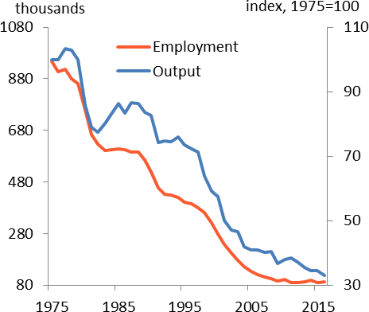Source: ONS Source: ONS

What can we say about the balance of these effects?

The red line in Chart 7 plots the estimated gains to consumers from lower prices over this period, relative to an assumed “non-globalisation” path of 1¼% per year. As I said above, the actual and more pronounced declines have delivered a real income gain for consumers of around 3%.

The blue line plots the estimated loss in labour income in the sector. Because we’ve assumed real prices would continue to fall somewhat, even in the absence of globalisation, the industry would probably have to have slimmed down a bit (falling prices have to be matched by falling average costs). In a plausible scenario, consistent with the assumed 1¼%-per-annum rate of (real) deflation, job numbers would have fallen by around a quarter3. Most would have been saved, however, and the simulated path of aggregate wages in the sector would now be materially higher, by around 1¼% of household consumption.

1. Details of this “no-globalisation” simulation are available on request. With a sufficiently simple production set-up it turns out that, if productivity in one sector grows sufficiently fast to produce a relative price decline of 1% a year, then in a closed economy its share of employment will fall by (1-σ) a year, where σ is the demand elasticity of substitution between the two goods. This makes sense: the greater the elasticity the bigger the response to demand to the drop in price for the good experiencing more rapid productivity growth; if, in particular, σ>1, employment would actually rise. As it is, the UK data suggest the σ for clothes is 0.44, plus or minus. We have fixed the rate of real price deflation in clothes at 1¼%, matching the observed rate before 1975 and after 2008, so the simulated “

no-globalisation” change in the share of clothing employment is -1.25 x (1-0.44) =-0.7% per year, relative to aggregate employment. The simulation also assumes the same skill-mix and therefore the same relative wage (compared with the national average) as in 1975.

|  |  |
| --- | --- |
| **Chart 7: Aggregate gains to consumers much larger than income losses, even assuming lost jobs weren’t replaced** | That’s a sizeable number – around £15bn. But bear in mind two things. It’s clearly much smaller than the estimated gross gains for consumers (£36bn); in addition, it’s almost certainly a significant  over-estimate of the true losses. The blue line is the estimated cumulative impact of globalisation on aggregate labour income *in this particular sector*.  Those are losses for the whole economy only if you believe the jobs lost in clothing and textiles weren’t ever replaced by any others.  Yet there’s a big difference between particular jobs and overall employment. Individual jobs are lost continually. The official UK series on redundancies goes back to the mid-1990s. |
| Source: ONS and own calculations |  |

Since then, on average, there have been over 600,000 a year, not far from the number lost in the clothing industry over the past forty years. Yet aggregate employment has risen – since both the mid-1970s and the mid-1990s – and the rate of unemployment has fallen. In any reasonably flexible labour market new jobs are created as others are destroyed.

This means the blue line is very much a ceiling on the gross losses. Allowing for the (very strong) likelihood that the jobs lost in the clothing sector have been replaced by new jobs in other sectors, a more realistic estimate would be closer to the origin, and the estimated net gains from globalisation all the greater.

# Trade, technology and distribution

This simple comparison is quite striking. As any economist reading this will know well, however, it’s not the end of the story.

For one thing, I’ve focussed on a sector in which the UK looks already to have had a comparative disadvantage in the 1970s. If you start as net importer of a particular good, the benefits of lower prices will necessarily outweigh the costs4. More generally it’s very difficult to construct a scenario in which free trade is not a net benefit, certainly for a relatively small economy like the UK. But the position is less clear than in

1. If you produce Y of some consumption good and consume C of it, the net income effect of a price change ΔP is ΔP(Y-C). The difference between domestic production and consumption, Y-C, is the trade balance. So if you happen to be a net importer of the good (Y<C) a drop in international prices makes you better off: all else equal, it boosts your “terms of trade”.

Chart 7 if a country already open to trade is faced with a fall in prices in a sector where it has a comparative advantage5.

Second, you might well object to such a crude, utilitarian comparison anyway. The gains are distributed across lots of people, the losses – such as they are – visited on only a few. Even if aggregate employment seems unperturbed by those sectoral job losses, and even when there are big net income gains in aggregate, that doesn’t mean no individual will have lost out.

Charts 8a and 8b are interesting in this respect. Using numbers from the decennial UK census, they plot developments in regional labour markets since 1981 – in particular changes in aggregate employment and labour market participation – against the share of employment in clothing and textiles at the start of the period.

|  |  |
| --- | --- |
| **Chart 8a: Regions with larger clothing sectors in 1981 tended to experience slightly lower growth in overall employment over following decade** | **Chart 8b: This was reflected in higher inactivity rather than unemployment** |
| Source: UK Census, Nomis | Source: UK Census, Nomis |

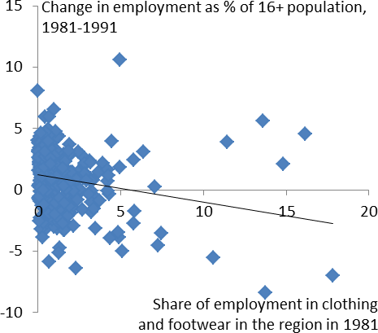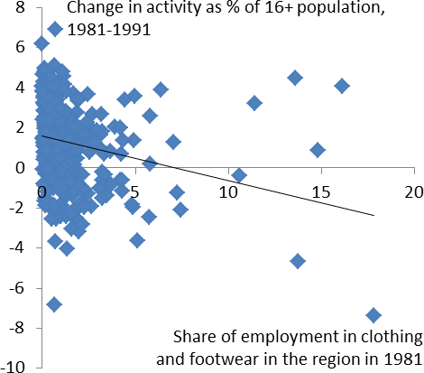There’s clearly lots of unexplained variation. Most of these regional differences are entirely unrelated to the particular starting conditions. Nor is there any correlation at all, it turns out, between the initial share of clothing and textile employment and what happens subsequently to the local rate of unemployment.

1. Samuelson (2004) points out that, if country A starts to experience rapid productivity growth in a good in which another country B has had a comparative advantage, and is large enough to affect global prices in that good, this can worsen B’s terms of trade sufficiently to reduce its net income. If (for example) B has traditionally been very good at making mousetraps, and A suddenly finds a new and cheaper way of making them, B could end up worse off (at least until it gets better at something else). So, although some trade is always better than none, there are settings in which – given the existence of trade – changes in relative productivity can worsen a country’s welfare.

But you do see something in employment and participation. Relative to others, regions with larger-than- average clothing sectors in 1981 experienced slightly lower growth in employment, and slightly greater rises in economic inactivity, over the following ten years (Charts 8a and 8b). Even in the 2011 census (Charts 9a and 9b) there still seems to be something of an echo of the pattern of employment thirty years earlier.

|  |  |
| --- | --- |
| **Chart 9a: Even after 30 years the negative correlation with employment still exists** | **Chart 9b: Same goes for inactivity** |
| Source: UK Census, Nomis | Source: UK Census, Nomis |

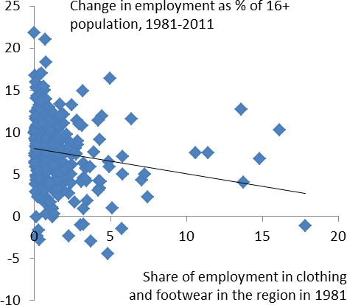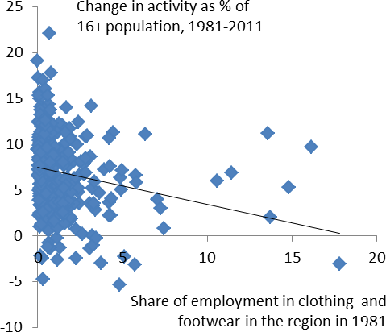From such bare-bones relationships any conclusion can only be tentative. They don’t control for any other differences that might have existed in 1981 and it’s possible the correlations are picking up something other than the size of the local clothing and textile industry. However, the results do happen to accord with other, much more careful studies. In the United States, David Autor and co-authors6 have found that individuals working in industries and regions more exposed to trade with China have subsequently seen longer than average periods of non-employment. This is particularly true for those at the lower end of the distribution. Pessoa (2016) finds similar results for the UK in the years following China’s accession to the WTO.

Further, even if people are re-employed relatively quickly after an industry shrinks, there’s no guarantee they’ll get the same wage. Economics certainly doesn’t say rising import penetration means permanently fewer jobs, but it does suggest that, if you suddenly open up trade with a country with a plentiful supply of unskilled labour, that can reduce the wages of less-skilled people at home7. The Pessoa (2016) study finds that, among the bottom 10% of earners in the UK, those in industries more exposed to trade with China saw a drop of around 4% in their total earnings (relative to others) over the following few years. This is partly the

1. Autor et al (2013).
2. Stolper and Samuelson (1941)

result of slightly longer periods of non-employment. It’s also because they got less well paid in their new jobs8.

More generally, the growth in trade with developing economies has been suggested as one possible explanation of the widening dispersion of wage and income inequality in the United States (the red line in Chart 10).

# Chart 10: UK income inequality rose in 1980s but, unlike the US, has since been stable

Gini coefficient 50

UK

US

45

40

35

30

25

20

1961 1971 1981 1991 2001 2011

Source: IFS, ONS and World Bank

Yet after a lot of work on this question – the economics literature on the growth of income inequality in the US is vast – I think it’s fair to say that rising trade can only account for a minority of the trend. For example, conventional theory would suggest that, while it might lower the relative wage of unskilled labour in developed economies, rising trade should do the opposite in developing economies.

Yet wage inequality has risen in many developing economies as well, including those whose exports to the US have grown rapidly. Separately, Paul Krugman9 has argued that, while it may have gone up a lot, the volume of US trade with developing economies simply isn’t big enough to have had a very significant bearing on relative wages.

And in some countries where import penetration is higher – the UK is one – the rise in income equality has been smaller than in the US. As measured by the conventional Gini coefficient, income inequality in this country has been broadly flat since the late 1980s, precisely the period over which trade with developing economies has grown most rapidly (Chart 10 again). Overall, the evidence that trade has depressed the wages of unskilled workers in the developed world is mixed at best10.

Instead, most economists have argued that the more important factor behind rising wage inequality in the United States has been the “skill-biased” nature of technical progress – the fact that computer technology seems to have added more to the productivity of high-skilled than lower skilled employees. One recent and well-publicised IMF study made the same point (Chapter 3, World Economic Outlook, April 2017) but this is only the latest in a very extensive and long-lived literature that has reached broadly similar conclusions.

1. Note that this could reflect the effect of a period of unemployment – so-called “scarring” – and needn’t say anything about the impact of trade on wages.
2. Krugman (1995).
3. Harrison et al. (2011) provide a useful survey; Haskell and Slaughter (2003) provide a careful anaylsis designed to distinguish the

effects on wage inequality of both technology and trade and find only weak effects of the latter; Stone and Cavazos Capeda (2012) find some effect of imports on wage differentials but, allowing for their impact on productivity, positive effects across the distribution.

I can’t possibly do any real justice to this work. Nor should I over-state its results. None of it attributes everything to the nature of recent technical progress or dismisses entirely the impact of trade on inequality. There may in any case be interactions between the two11. And even when there aren’t, their effects can be quite similar and therefore difficult to distinguish from one another. To generalise, increases in trade and technological innovations both tend to improve overall well-being but, by producing sharp shifts in relative prices, they can also make some people worse off, at least for a period of time.

The early classical economists certainly recognised the parallels between technological improvements and free trade. Aware too that the public tended instinctively to support the former12, they used these parallels to persuade people of the virtues of the latter. Here, for example, is lawyer and proto-economist Nassau Senior, writing in 182813:

“If we should think it madness to prohibit, or to tax, the use of an improved steam-engine, because it must be injurious to those employed in raising coal, what pretence is there for prohibiting or taxing foreign ribands or velvets because their importation would be injurious to the English silk-weaver? To prohibit every change which is accompanied by individual injury would be to prohibit every improvement whatever”.

This is heavily rhetorical but the question could still be asked today. At least in advanced economies many people are doubtful about the benefits of trade (a Pew Research survey in 2014 found that only 28% thought it helped to lower prices and thereby improve real incomes). But if the economics literature is right about the greater impact of new technology on the distribution of income, at least in the US, how many would say we should tax computer investment?

**The distribution of the benefits:** I want to end this section with something else the early economists would recognise – that, whatever it has done to widen the distribution of income, free trade with labour-rich countries can have significantly *progressive* effects on prices.

In their early writings on international trade the classical economists reserved particular hostility for the Corn Laws. Introduced after the Napoleonic Wars, in the midst of an economic downturn, these measures imposed heavy restrictions and tariffs on agricultural imports. The result was a much higher price of food, benefiting agricultural landowners14 and penalising the less well-off, for whom food was the major part of their consumption. Their eventual repeal in 1846, a landmark in Britain’s move towards (and support for) free trade in the second half of the century, owed much to the intellectual arguments of the classical economists. But it also came about because of what those restrictions meant for the poor.

1. See for example Acemoglu (1998) and Behar (2013).
2. There are some obvious historical exceptions to this support. In 1779, there was a spate of “anti-machinery” riots. In one of them,

Richard Arkwright’s new mill in Birkacre, in Lancashire, was destroyed. Thirty years later the “Luddites”, formed mainly of textile workers, also sought to destroy labour-replacing weaving machinery.

1. Quoted in Irwin (1996).
2. The campaigner Richard Cobden described the opponents of Corn Law abolition as “the bread-taxing oligarchy, unprincipled,

unfeeling, rapacious and plundering”.

Again, it is worth remembering this point today. Much of the work on trade and inequality focuses on the potentially differential effect on wages and employment. The gross costs of trade may not be evenly distributed. As Chart 11 demonstrates, however, the gross benefits of lower import prices are probably skewed as well. On average, things that are more tradable are also consumed disproportionately by the less well-off.

It turns out this pattern is common to all developed economies. Chart 12 is taken from a recent study by Fajgelbaum and Khandelwal (2016), describing what would happen to relative consumer prices, and thereby the distribution of income, if international trade with the developing world were suddenly shut down. In every country, including the UK, it’s the less well-off who would be worse affected by the consequent rise in prices.

|  |  |
| --- | --- |
| **Chart 11: Benefits of lower import prices are skewed towards the less well-off** | **Chart 12: This is also true in other developed economies** |
| Source: Living Costs and Food Survey, ONS | Source: Fajgelbaum and Khandelwal (2016); Note: Chart shows real income loss from cutting off trade. |

# Conclusion

One often hears that political discontentedness reflects rising income inequality and that this, in turn, is the fault of the growth in trade. It is the cry of the “losers from globalisation”.

It’s certainly possible that people *perceive* that trade has reduced developed-country real incomes. More generally, it’s clear that it’s not intuitively obvious to people that international trade is of mutual benefit.

Paul Samuelson, when asked by a mathematician at MIT for a result in economics that was both true and counter-intuitive, cited the principle of comparative advantage:

“That this idea is logically true need not be argued before a mathematician; that it is not trivial is attested by the thousands of important and intelligent men who have never been able to grasp the doctrine for themselves or to believe it after it was explained to them15 ”.

It’s also likely that some sectors have indeed lost from globalisation – growth in trade has probably contributed to the decline in industrial employment in the developed world. But that hasn’t meant lower employment in aggregate and the drop in tradable prices has, in the meantime, brought significant benefits for consumers. These are particularly marked for the less well-off.

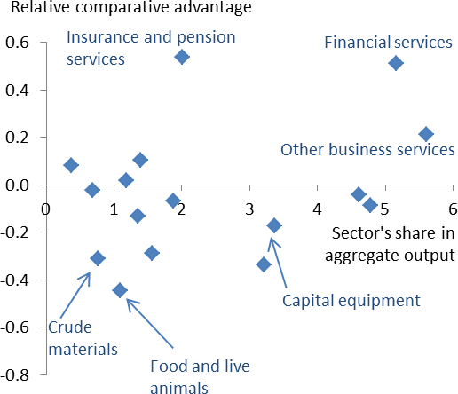What, then of Brexit? Well, obviously the EU economies are highly developed, so our trade with Europe – which is extensive – is less skewed towards labour intensive goods and services than that with developing economies. Nevertheless, it has allowed for a great deal of specialisation. And if the theme of this talk is that the benefits of trade involve imports as much as they do exports, the same point applies. Put simply, a significant curtailment of trade with Europe would force the UK to shift away from producing the things it’s been relatively good at, and therefore tends to export to the EU, and towards the things it currently imports and is relatively less good at.

|  |  |
| --- | --- |
| **Chart 13: UK’s revealed comparative advantage with the EU** | Chart 13, which plots “revealed comparative advantage” in each sector – roughly speaking a rescaled version of the balance of trade with the EU  – gives some idea of what these sectors are: we tend to export services, financial services in particular, and import goods, notably food and capital equipment.  All else equal, the first shift (i.e. away from services exports) would tend to lower UK income, the second to raise certain costs (that is, of food and machinery). And, albeit on a smaller scale, relative to their (much larger) GDP, the same would be true for the EU16.  Trade really is mutually beneficial and less of it costs us all. That these truths are a couple of centuries old, and not always widely accepted, doesn’t make them any less true. |
| Source: UNCTAD and ONS; Note: Gross value added was used as output. Revealed comparative advantage is expressed as the ratio of a sector’s share in UK’s exports to the EU to its share in trade with EU. A value larger than 0 of a sector means that the UK  has a revealed comparative advantage in that sector. |

1. Paul Krugman (1998), irritated especially by opposition to international trade among contemporary intellectuals, suggested it may partly reflect a preference for the modern and unorthodox over long-established ideas, even when they’re still true: “[Try] telling an ambitious, energetic, forward-looking intellectual…that before he can start talking knowledgeably about globalisation he must wrap his mind around a difficult concept that was devised by a frock-coated banker 180 years ago”.
2. The Governor recently commented on the potential impact of Brexit on the cost of financial services in the EU (Carney (2017))

# References

**Acemoglu D.,** 1998, ‘Why Do New Technologies Complement Skills? Directed Technical Change and Wage Inequality’, *Quarterly Journal of Economics*, 113(4):1055-1089.

**Autor, D., Dorn D., and G. Hanson**, 2013, ‘The China Syndrome: Local Labor Market Effects of Import Competition in the United States’, *American Economic Review*, 103:6, pp. 2121-68.

**Autor, D., Katz L. and M. Kearney**, 2006, ‘The polarisation of the U.S. labour market’, *NBER* Working Paper no. 11986.

[**Baldwin**](http://www.nber.org/people/richard_baldwin) **R.,** 2011, **‘**Trade and industrialisation after globalisation's 2nd unbundling: How building and joining a supply chain are different and why it matters’, *NBER Working Paper* No. 17716.

**Behar A.,** 2013, ‘The Endogenous Skill Bias of Technical Change and Inequality in Developing Countries’,

*IMF Working Paper* no 50.

**Carney M**., 2017, ‘A fine balance’, Speech given at Mansion House and available here <http://www.bankofengland.co.uk/publications/Documents/speeches/2017/speech983.pdf>

**Fajgelbaum, P.D. and A.K. Khandelwal,** 2016, ‘Measuring the Unequal Gains from Trade’, *Quarterly Journal of Economics*, Vol. 131.

**Harrison A., McLaren J. and M. McMillan**, 2011, ‘Recent perspectives on trade and Inequality’, *Annual Review of Economics*, Vol. 3, pages 261-289.

**Haskel J. and M. Slaughter**, 2003, ‘Have falling tariffs and transportation costs raised US wage inequality?”, Review of International Economics, Vol. 11, Issue 4, September, pp. 630-650.

**Jacks D., Meissner C., and D. Novy,** 2011, Trade booms, trade busts, and trade costs’, *NBER Working Paper* No. 15267.

**Keller C., Wieladek T., Gun D. and S. Kochugovindan,** 2017, ‘The future of globalisation’, *Barclays research.*

**Krugman P.,** 1995, ‘Growing world trade: causes and consequences’, *BPEA* no. 1, pages 327-377.

**Krugman P.,** 1996, ‘Ricardo’s difficult idea’, paper presented at the Manchester conference in free trade and is available [here](http://web.mit.edu/krugman/www/ricardo.htm)

**Krugman P.**, 2008, ‘Trade and Wages, Reconsidered’, *Brookings Papers on Economic Activity*, no. 1.

**Pessoa J. P., 2016**, ‘International Competition and Labor Market Adjustment’, CEP Discussion Papers dp1411, *Centre for Economic Performance*, LSE.

**Samuelson P.**, 2004, ‘Where Ricardo and Mill rebut and confirm arguments of mainstream economists supporting globalisation’, *Journal of Economic Perspectives*, Vol 18, No. 3, pages 135-146.

**Stone S. F. and H Cavazos Cepeda**, 2012, ‘Wage Implications of Trade Liberalisation: Evidence for Effective Policy Formation’, Policy Priorities for international trade and jobs, OECD.